KAVIRAYANI SENIOR SECONDARY SCHOOL
PARVATHIPURAM
Activity Sheet 3 Class – IV & V
Mental Ability

Guess me
IV Use the digits in the box to answer each riddle.
2 4 9 6 7 3

- The sum of these three 2-digit numbers is 184.
What are the numbers ______ ______ ______
- When you subtract a 2 –digit number from a 3-digit numbers, the difference is 473.
What are the numbers ______ ______ ______

V Solve these
1. What is the least number of ducks that cam swim in this formation –
two ducks in front of a duck, two ducks behind a duck and a duck two ducks?
____________

2. If 100 cats kill 100 mice in 100 days, then 4 cats would kill 4 mice in how many days?
____________
VI Missing Number
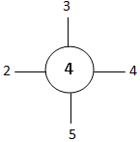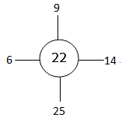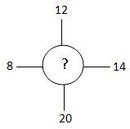

16
5
3
240
10
4
6
240
12
5
3
?

