KAVIRAYANI SENIOR SECONDARY SCHOOL
PARVATHIPURAM
Activity Sheet 1 Class – VI & VII

Problem Solving Assessment

A. Make meaningful words using the clues.
For Example : C T E K R I C A game Cricket
- I A T W R O : One who works in a hotel. _______________
- II R E P L : A weapon. _______________
- T G D E A I R T U: Being thankful _______________
- N A G E D L N : A country _______________
- J A M O R : An army officer _______________

B. Fill in with suitable words:
1. Time is to clock temperature is to ________________
2. Milk is to cow honey is to _______________
3. Lucknow is to Uttar Pradesh Kohitna is ____________
4. Air force is to air Navy is to _______________
5. Roar is to tiger bleat is to ______________

Q. Write a short paragraph about ‘Swachh Bharat’ Programme in 100 words.
Mental Ability
A. Find out the missing number.

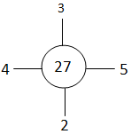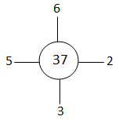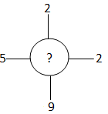
15
28
30
12
20
20
6
16
?
85
70
93
60
57
625
169
225

